

ITS64604 Software Engineering
MLO 3: Demonstrate subject specific skills with respect to applying modelling techniques and notations in the group project coursework.
Student declaration:
I declare that:
- I understand what is meant by plagiarism
- The implication of plagiarism have been explained to us by our lecturer
This project is all our work and I have acknowledged any use of the published or unpublished works of other people.
GROUP NAME:  Kilo 3 |  | Signature
Name | Student ID
1. Sureena Kulasingam | 0361424 | 
2. Ramisa Tasnim | 0374738 | 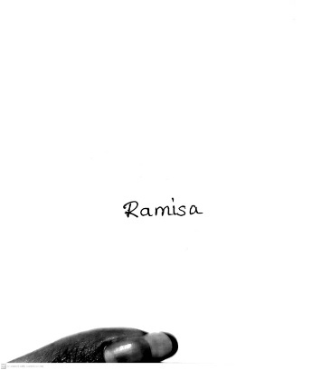
3. WuBin | 0374383 | 
4. Liang Guodong | 0375147 | 梁国栋
5. Geng Biao | 0379533 | 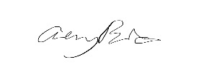

Declaration (need to be signed by students. Otherwise, the assessment will not be evaluated)
Certify that this assignment is entirely my own work, except where I have given fully documented references to the work of others, and that the material contained in this assignment has not previously been submitted for assessment in any other formal course of study.

Marks/Grade: | Evaluated by:

Table of Contents
Individual Diagrams 6
Individual Rubrics 22
1.0 Introduction 23
1.1 Problem Statement 23
1.2 Proposed Solution 23
2.0 Requirement Analysis 23
2.1 Requirement Elicitation 23
2.2 Requirement Specification 26
2.3 Software Validation 28
3.0 Scope Definition 31
4.0 System Design 33
4.1 SDLC Model 33
4.2 GUI Storyboard 35
4.3 GUI Design 36
4.4 Use Case Diagram 50
4.5 Class Diagram 52
4.6 Sequence Diagram 53
5.0 Conclusion 55
Group Rubrics 56

List of Figures
Figure 1-Sureena's Order Fulfilment System Use Case Diagram 5
Figure 2-Sureena's Food Ordering System Class Diagram 6
Figure 3-Ramisa's Order Fulfilment System Use Case Diagram 8
Figure 4-Ramisa's Food Ordering System Class Diagram 10
Figure 5-Wubin's Order Fulfilment System Use Case Diagram 13
Figure 6-Wubin's Food Ordering System Class Diagram 14
Figure 7-Liang's Order Fulfilment System Use Case Diagram 15
Figure 8-Liang's Food Ordering System Class Diagram 16
Figure 9-Geng Biao's Order Fulfilment System Use Case Diagram 17
Figure 10-Geng Biao's Food Ordering System Class Diagram 18
Figure 11-Prototype Model Concept 32
Figure 12-Storyboard of Hotelcatz Website 33
Figure 13-Home Page 34
Figure 14-Booking & Services preview in Home Page 35
Figure 15-Happy Guests Section in Home Page 36
Figure 16-Booking & Services Page 37
Figure 17-Service Page 38
Figure 18-Booking Calendar Page 39
Figure 19-Gallery Page 39
Figure 20-Blog Page 40
Figure 21-About Us Page 41
Figure 22-Sign up and Log in Page 41
Figure 23-Admin Navigation Bar 41
Figure 24-Password Page 42
Figure 25-Admin Home Page 43
Figure 26-Admin Booking Page 43
Figure 27-Admin Gallery Page 44
Figure 28-Add New Image Feature 44
Figure 29-Admin Blog Page 45
Figure 30-Admin About Page 46
Figure 31-Admin Contact Page 47
Figure 32-Admin Add New Page 47
Figure 33-Back to User Page 48
Figure 34-Hotelcatz Use Case Diagram 48
Figure 35-Hotelcatz Class Diagram 50
Figure 36-Hotelcatz Sequence Diagram Part 1 51
Figure 37-Hotelcatz Sequence Diagram Part 2 52

List of Tables
Table 1-Functional and Non-Functional Features
Table 2-Overall System Testing
Table 3-Feature Specific Test Cases

Individual Diagrams
- Sureena Kulasingam (0361424)
- Use Case

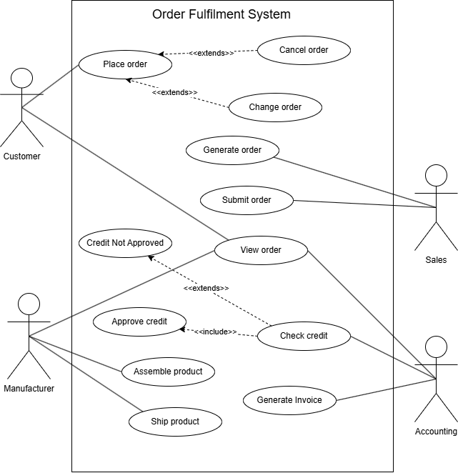
Figure 1-Sureena's Order Fulfilment System Use Case Diagram
This figure represents the Use Case Diagram of an Order Fulfilment System, which involves four main actors: Customer, Sales, Accounting and Manufacturer. The process begins with the Customer placing an order and if necessary, they have the option to change or cancel their order which is why these use cases have an << extends>> relationship with “Place order”. Once the order is placed, the Sales department will generate the order and submit it to the Accounting department. The Accounting department will then view the order and check whether the customer has enough credit. If the credit is not enough, the use case "Credit Not Approved" will be triggered, therefore, there is an <<extend>> relationship between the use cases. However, if the credit is approved, the accounting department generates an invoice and proceeds with the order. Finally, the Manufacturer will assemble the product and ship it to the customer. Additionally, the order can be viewed by the Customer, Accounting department and the Manufacturer, hence they are connected to the “View order” use case.
- Class Diagram

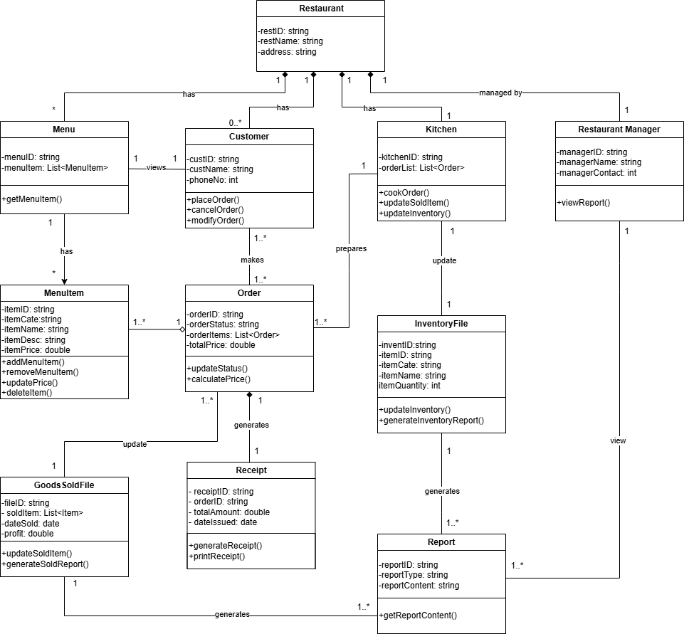
Figure 2-Sureena's Food Ordering System Class Diagram
This figure represents a Class Diagram of a Food-Ordering System and shows the relationships between various classes. The Restaurant is managed the Restaurant Manager and has multiple Menus, Customers and a Kitchen. The Customer can view the Menu which consists of different MenuItems. After selecting the items the Customer wants, they place an Order which is prepared by the Kitchen. Customers have the option to modify or cancel their order, reflected in the 0..* cardinality. Each order can contain one or multiple MenuItems, hence the One-to-Many relationship. Once the order is prepared, the Kitchen updates the InventoryFile to track inventory. The order is then recorded in the GoodsSoldFile and upon payment, a receipt will be generated. At the end of the day, the InventoryFile and GoodsSoldFile will generate their daily report which is later viewed by the Restaurant Manager.

- Ramisa Tasnim (0374738)
- Use Case
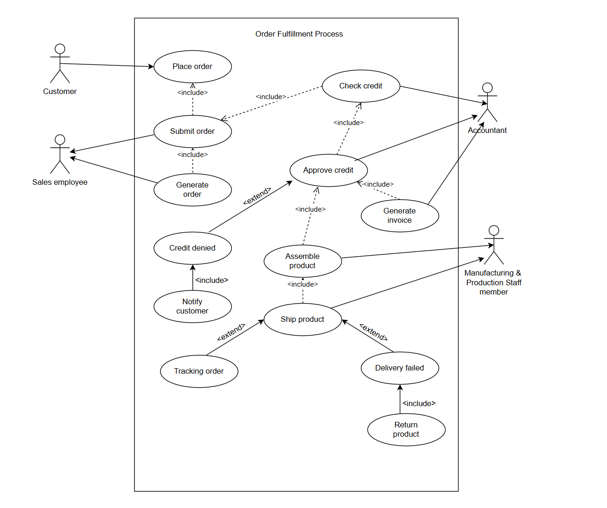
Figure 3-Ramisa's Order Fulfilment System Use Case Diagram
This use case diagram represents the process of handling customer orders from initiation to delivery. The key actors are:
- Customer
- Sales Employee
- Accountant
- Manufacturing & Production Staff Member
Key Use Cases & Relationships
- Place Order - The customer initiates the order process.
- Submit Order & Generate Order - The salesperson is responsible for submitting and generating the order.
- Check Credit & Approve Credit - The accountant is responsible for checking and approving credit.
- Generate Invoice - The accountant generates the invoive once the credit is approved.
- Assemble & Ship Product - Manufacturing & Production Staff are responsible for this..
- Tracking Order - Manufacturing & Production Staff can track the order.
- Credit Denied & Notify Customer - If the credit check fails, the accountant is responsible for this process.
- Delivery Failed & Return Product - If a shipment fails, the Manufacturing & Production Staff initiates this process.

Include & Extend Relationships
<include> relationship:
- Submit Order includes Check Credit - Every order must undergo a credit check before approval.
- Approve Credit includes Generate Invoice - Once approved, an invoice must be created.
- Approve Credit includes Assemble Product - Once credit is approved, production starts.
- Assemble Product includes Ship Product - Every assembled product must be shipped to complete the order.
- Credit Denied includes Notify Customer - If credit is denied, the customer must be informed.
- Delivery Failed includes Return Product - If delivery fails, the product must be returned.
<extend> relationship:
- Check Credit extends Approve Credit - A credit check does not always result in approval so approval is conditional.
- Ship Product extends Tracking Order - Orders can be tracked, but it is optional.
- Ship Product extends Delivery Failed - Delivery failure is a possibility but does not always happen.

- Class Diagram
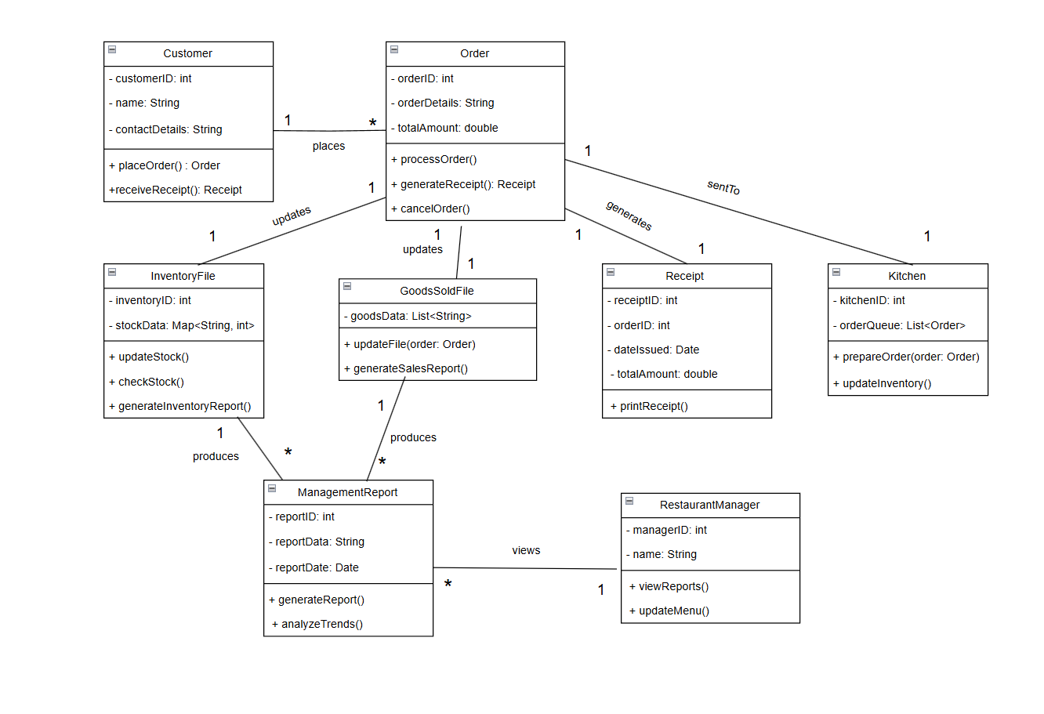
Figure 4-Ramisa's Food Ordering System Class Diagram
The class diagram represents the structure of the Food Ordering System. The breakdown of each class and its functionality has been given below:
1. Customer
- Attributes: customerID, name, contactDetails
- Methods:
  - placeOrder(): Allows the customer to place an order.
  - receiveReceipt(): Customer receives a receipt after order processing.
- Relationships:
  - One to many relationship with Order.
2. Order
- Attributes: orderID, orderDetails, totalAmount
- Methods:
  - processOrder(): Processes the order.
  - generateReceipt(): Generates a receipt.
  - cancelOrder(): Cancels an order.
- Relationships:
  - One to one relationship with InventoryFile, GoodsSoldFile, Receipt and Kitchen.
3. Receipt
- Attributes: receiptID, orderID, dateIssued, totalAmount
- Methods:
  - printReceipt(): Prints the receipt.
- Relationships:
  - One to one relationship with Order.
4. Kitchen
- Attributes: kitchenID, orderQueue
- Methods:
  - prepareOrder(): Prepares the order.
  - updateInventory(): Updates inventory after preparing food.
- Relationships:
  - One to one relationship with order.
5. InventoryFile
- Attributes: inventoryID, stockData
- Methods:
  - updateStock(): Updates stock after each order.
  - checkStock(): Checks stock levels.
  - generateInventoryReport(): Generates a report on available inventory.
- Relationships:
  - One to one relationship with order and One to many relationship with ManagementReport.
6. GoodsSoldFile
- Attributes: goodsData
- Methods:
  - updateFile(): Updates the record of sold goods.
  - generateSalesReport(): Generates a report on sales data.
- Relationships:
  - One to one relationship with order and One to many relationship with ManagementReport.
7. ManagementReport
- Attributes: reportID, reportData, reportDate
- Methods:
  - generateReport(): Generates business reports.
  - analyzeTrends(): Analyzes sales and inventory trends.
- Relationships:
  - Many to one relationship with GoodsSoldFile, InventoryFile and RestaurantManager.
8. RestaurantManager
- Attributes: managerID, name
- Methods:
  - viewReports(): Allows the manager to view reports.
  - updateMenu(): Allows updating the restaurant's menu.
- Relationships:
  - One to many relationship with RestaurantManager

- WuBin (0374383)
- Use Case
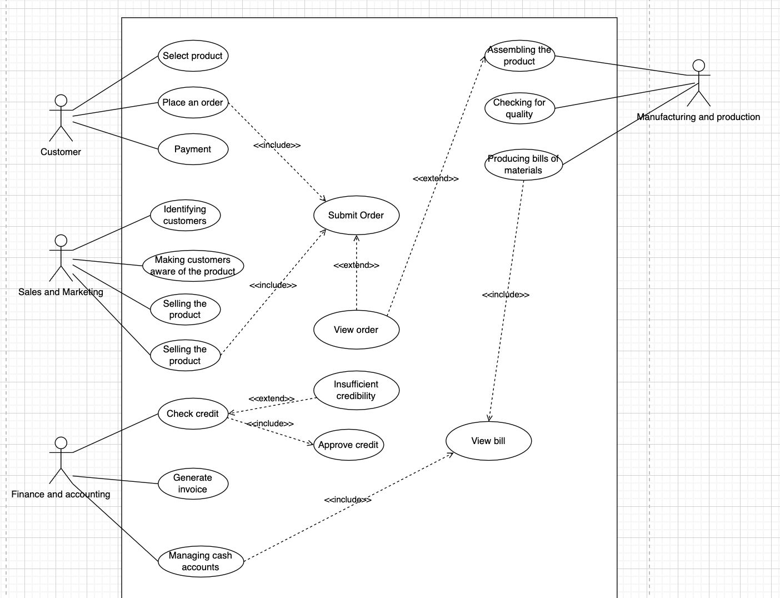
Figure 5-Wubin's Order Fulfilment System Use Case Diagram
This use case diagram shows that customers can select products, place orders and make payments, where "Submit Order" includes the payment process and may trigger an "Insufficient Credit" situation. The Sales and Marketing department is responsible for identifying customers, promoting and selling products. The Finance and Accounting department performs credit checks and needs to approve credit and is also responsible for generating invoices and managing cash accounts. The Production and Manufacturing department is responsible for product assembly, quality inspection and bill of materials generation to ensure smooth production of orders. After the order is submitted, the user can "View Order" and finally "View Bill". This system covers the complete business process from order submission, credit check, production and manufacturing to financial processing.
- Class Diagram
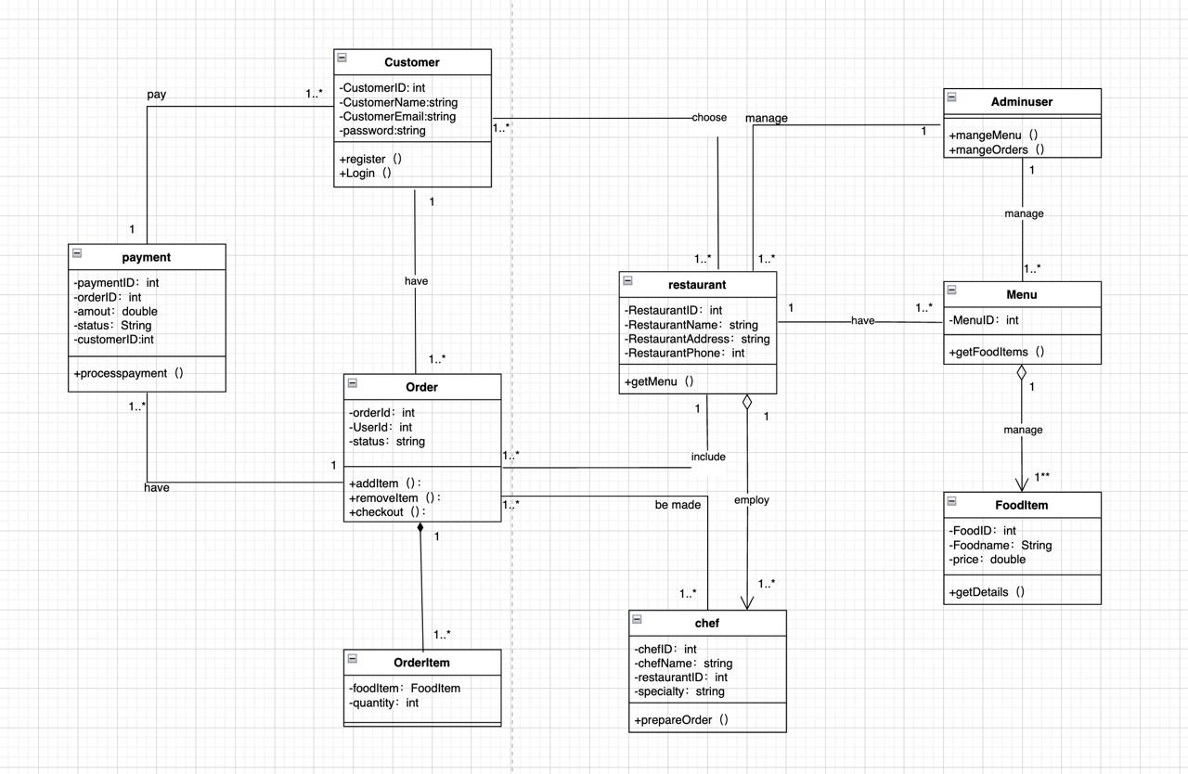
Figure 6-Wubin's Food Ordering System Class Diagram
This class diagram shows the core structure and relationships in a restaurant management system. Customers can register, log in, select a restaurant, and place an order, which contains multiple food items and is completed by payment. The restaurant provides a menu with a variety of food items and hires chefs to prepare the orders. Orders are created by customers, allowing them to add or remove items before checking out. Payments are associated with orders, recording the amount and status. Admin users manage menus and orders. The entire system covers the entire process from placing an order and payment to the chef completing the order, simplifying restaurant management.

- Liang Guodong (0375147)
- Use Case
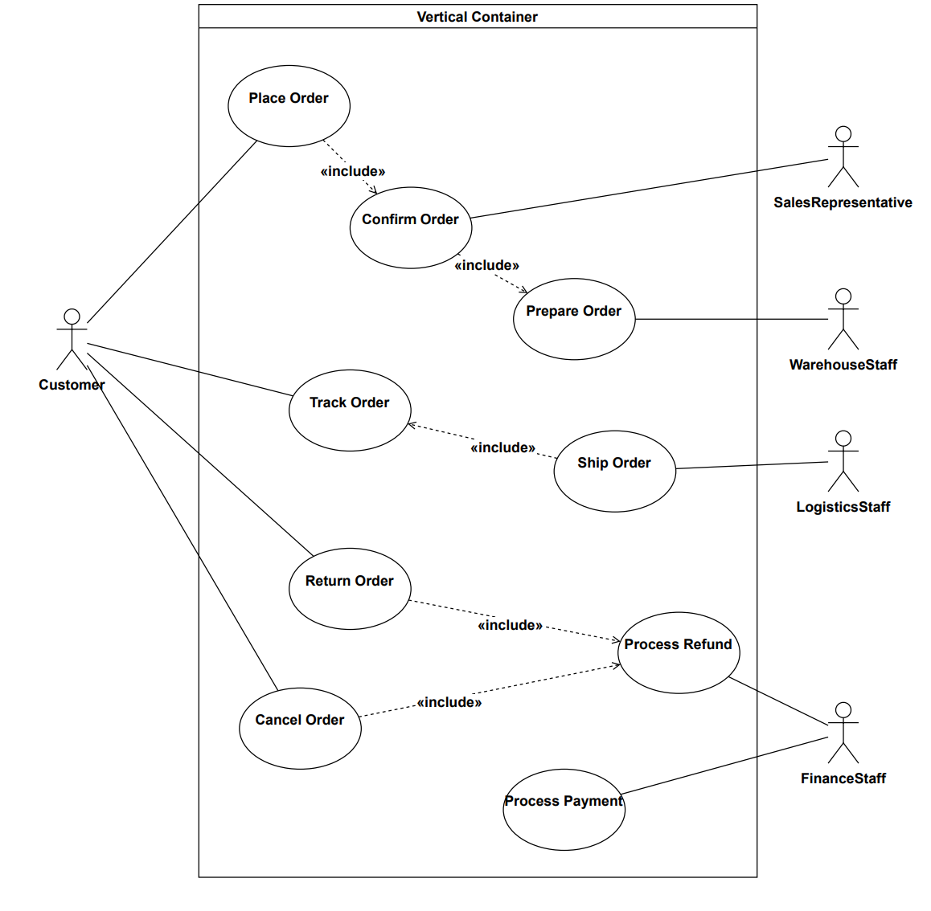
Figure 7-Liang's Order Fulfilment System Use Case Diagram
The diagram takes the customer as the core to initiate various order - related operations. After the customer places an order, the sales representative confirms the order, and this step is included in the order - placing process. After confirmation, the warehouse staff prepares the order, which is included in the order - confirmation process. The customer can track the order, and the logistics staff's order - shipping is included in the order - tracking process. When the customer initiates return or order - cancellation operations, the finance staff processes refunds and payments respectively, and these operations are included in the return and order - cancellation processes respectively. Each participant has a clear responsibility, and the use cases are closely linked through the "include" relationship, jointly forming a complete order - processing business process.

- Class Diagram
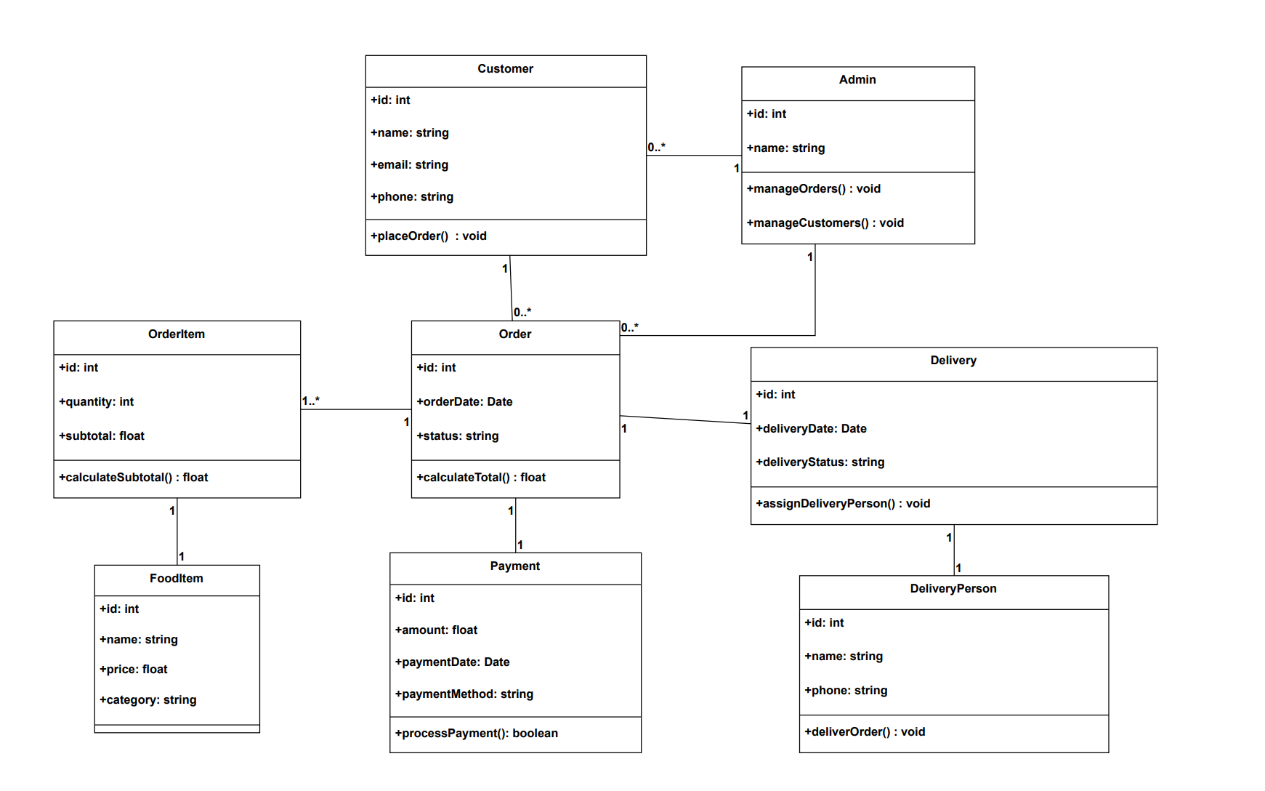
Figure 8-Liang's Food Ordering System Class Diagram
This class diagram illustrates a food - ordering system, which includes classes such as Customer, Admin, OrderItem, Order, Delivery, FoodItem, Payment, and DeliveryPerson. Customers can place orders, and admins can manage orders and customers. Orders are associated with order items, payments, and deliveries. Order items correspond to food items, and deliveries are carried out by delivery persons. All elements are connected with specific cardinality relationships, presenting the structure and business logic of the system.

- Geng Biao (0379533)
- Use Case
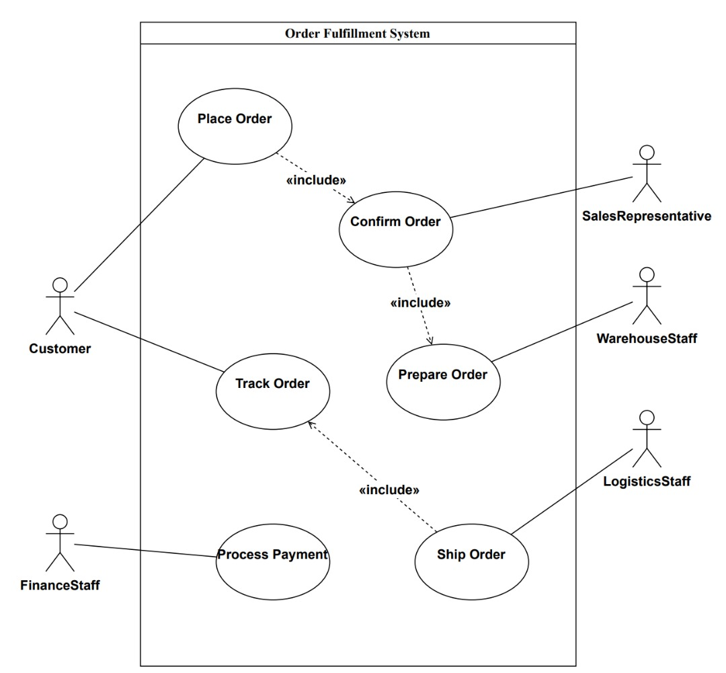
Figure 9-Geng Biao's Order Fulfilment System Use Case Diagram
This is a Use Case Diagram, which shows the main processes and roles of the Order Fulfillment System.
Customer: can place orders and track orders.
Sales representative: responsible for confirming orders and ensuring that the information is accurate.
Warehouse staff: prepare goods after the order is confirmed.
Logistics staff: responsible for shipping.
Financial staff: handle payments and ensure the smooth financial aspects of the transaction.
Use Case
Place an order: the starting point of the process.
Confirm the order: included in the order placement process, ensure that the information is correct.
Prepare the order: included in the order confirmation process, prepare for shipping.
Shipment: included in the order tracking process, send the goods to the customer.
Track the order: the customer can check the order status, including shipping operations.
Process the payment: ensure that the order payment is processed correctly.
The "«include»" relationship in the figure represents the inclusion relationship. For example, "Confirm Order" is included in "Place Order", which means that there must be an order confirmation step in the order placement process; "Prepare Order" is included in "Confirm Order", indicating that order preparation is required after confirming the order; "Ship Order" is included in "Track Order", indicating that shipping operations are involved in the order tracking process.
Through this use case diagram, we can clearly understand the responsibilities of each role in the order fulfillment system and the main process of order processing.
- Class Diagram
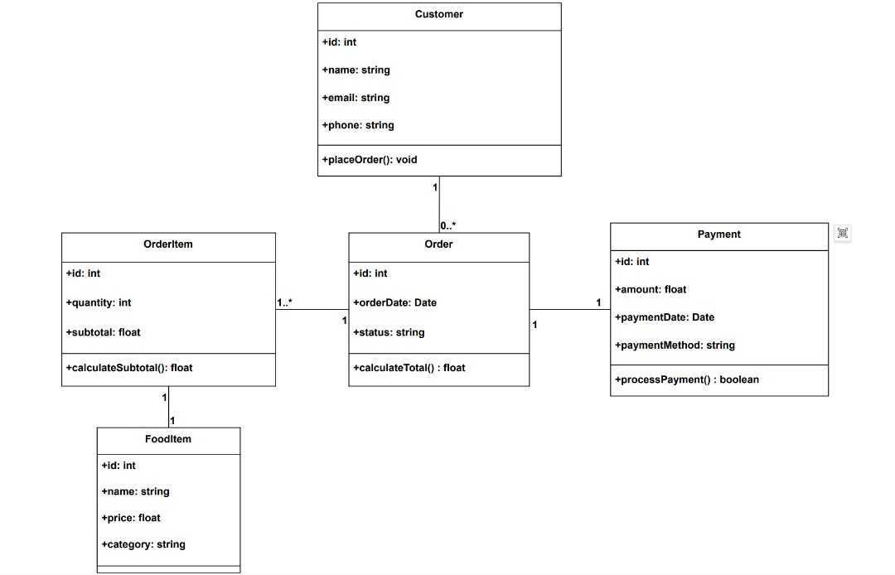
Figure 10-Geng Biao's Food Ordering System Class Diagram
Relationships between classes
Relationship between Customer and Order:
A customer can place 0 or more orders, which is represented by a 1-to-0..* relationship, i.e. a one-to-many relationship.
Relationship between OrderItem and Order:
An order can contain 1 or more order items, which is represented by a 1-to-1..* relationship, i.e. a one-to-many relationship.
Relationship between OrderItem and FoodItem:
An order item corresponds to a food item, and a food item also corresponds to an order item, which is represented by a 1-to-1 relationship, i.e. a one-to-one relationship.
Relationship between Order and Payment:
An order corresponds to a payment, and a payment also corresponds to an order, which is represented by a 1-to-1 relationship, i.e. a one-to-one relationship.
This class diagram provides a clear model for order-related business logic by defining classes, attributes, methods, and relationships between classes, which helps with system design and implementation during software development.

Individual Rubrics
Criteria (Weight) | Unacceptable (0)  0-2 | Marginal (1)  4-7 | Acceptable (2)  8-10 | Points
 |  |  |  | Student 1 | Student 2 | Student 3 | Student 4 | Student  5
Relationships between  concepts  (10) | Unclear relationship between concepts.  Components and sub-components unclear. | Relationship between concepts evident.  Components and subcomponents present. | Clear relationship between concepts.  Hierarchical organization between components ans sub- components.
Cross linkages  (10) | Linkages do not make sense and are not explained. | Logical linkages.  Explanation of linkages are unclear but information is accurate. | Logical linkages.  Explanation of linkages are clear but information is  accurate and precise.
Overall
Performance
(20)

Introduction
Hotelcatz is a company dedicated to providing quality hotel booking services. With the development of digitalization, customers' demand for online booking is increasing, and an efficient, beautiful and easy-to-manage website is crucial to Hotelcatz's brand image and business development. Therefore, members of our team will develop a new official website for Hotelcatz that will allow customers to easily book rooms while allowing Hotelcatz employees to manage the website content themselves without the need to regularly hire technical staff.

1.1 Problem Statement
The current website is hard to navigate which makes it difficult for customers to book rooms and access information. Staffs also struggle to update content without undergoing frequent maintenance or hiring developers. Additionally, the outdated design makes it less appealing to potential customers.

1.2 Proposed Solution
The website will have a modern web design to ensure that users can browse easily and obtain useful information. The new design will improve navigation and readability, making information easier to access and enhancing the user experience. It will also strengthen Hotelcatz’s brand image and attract more customers. Moreover, ensure that Hotelcatz staff can independently maintain and update website content without having to regularly hire an outside development team. Therefore, the website must have an easy-to-use content management system that allows its staff to easily add, modify and delete text, images, room information and blog content on the website.

2.0 Requirement Analysis
Before we begin the development process, it is important to establish clear goals and gather all necessary requirements. This helps ensure that the project stays on track, meets user needs and aligns with the overall vision for the website.

2.1 Requirement Elicitation
Requirement elicitation is a technique used to collect information for defining requirements of a product. This section presents the information gathered from Hotelcatz's official Instagram. These details include the services offered, pricing, hours of operation and contact information.
Company Profile Summary:
Facebook: MyCats
Instagram: Hotelcatz
Contact: Syahira 016-520 6095 / Suraya 016-941 6095
Operation Hours: 10am - 7pm
Lunch Break: 2pm-3pm
Closed on Wednesdays & Sundays
Location:16-1, Jalan Jenulung 17/21, Seksyen 17, 40200 Shah Alam, Selangor

Services:
- Hotel:
- RM15 per day (1 cat) for Normal days
- RM20 per day (1 cat) for Public Holidays
- RM30 per day (Mommy & kittens) less than 2 months max
- Additional RM5 per day (1 cat) for Additional Food
- Additional RM2 per cat for Napkins

- Spa Package:
- Includes bath, towel & blow dry, ear wash, tear stain wash and cutting nails
- RM55 less than 4kg
- RM75 less than 6kg
- RM90 less than 9kg

- Cat-tastic Package:
- Includes bath, towel & blow dry, ear wash, tear stain wash, cutting nails, paw trimming, dematt and rear fur trimming
- RM95 less than 4kg
- RM115 less than 6kg
- RM155 less than 9kg

- Pow-er Package:
- Includes bath, treatment shampoo, towel & blow dry, ear wash, tear stain wash and cutting nails
- RM70 less than 4kg
- RM90 less than 6kg
- RM110 less than 9kg

- Trimming Services:
- Paws Fur Trimming: RM 20
- Rear Fur Trimming: RM 20
- Dematting: RM 20 - RM 50
- Lion Cut Trimming (Adult): RM 35
- Bear Cut Trimming: RM 60

- Fur-ever Package (Fungus treatment):
- Includes bath, treatment shampoo, towel & blow dry, ear wash and tear stain
- RM70 less than 4kg
- RM90 less than 6kg
- RM110 less than 9kg

- Extra services (Spot on Flea):
- RM 18 less than 4kg
- RM 28 more than 4kg

Images:
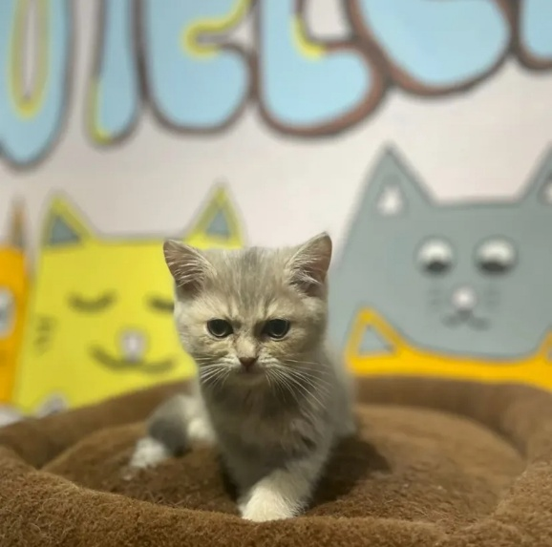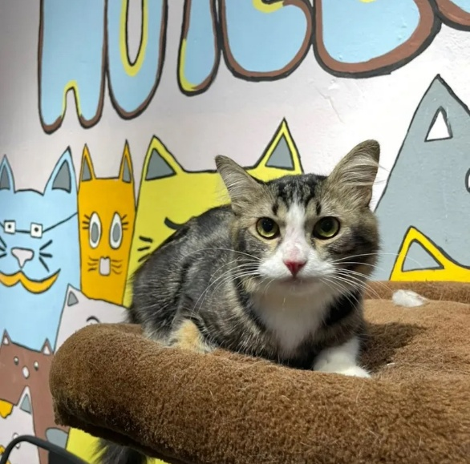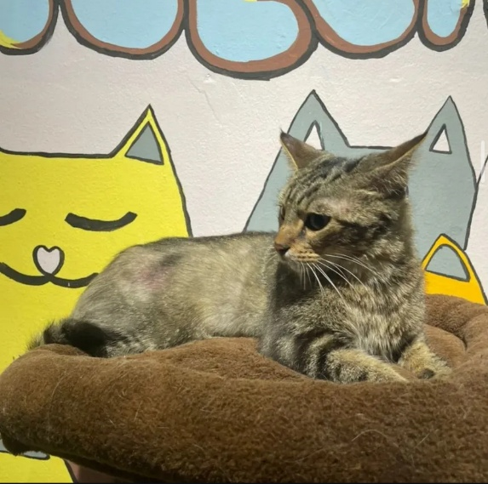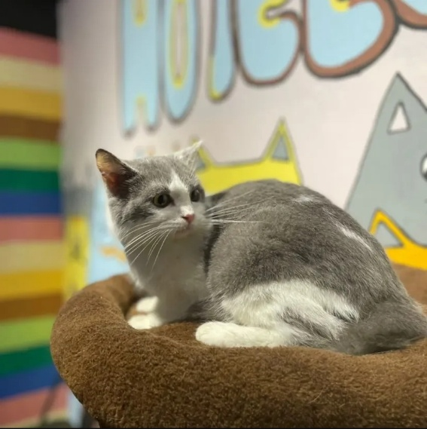

2.2 Requirement Specification
Based on the information we have gathered and analysed, we are able to identify the following functional and non-functional requirements for the website. Functional requirements are requirements that describes what the system should do, and non-functional requirements are requirements that define how the system should perform.
Table 1-Functional and Non-Functional Features
ID | Functional | ID | Non-functional
FR1 | Users will be able to create an account using their email, phone no. and password. | NFR1 | The account creation process should be user - friendly and secure, with proper data validation for email and phone number formats.
FR2 | Users will be able to log in and log out securely. | NFR2 | The login and logout mechanisms should use strong encryption and authentication techniques to ensure the security of user accounts.
FR3 | Users will be able to check room availability in real-time. | NFR3 | The real - time room availability check should have a response time within an acceptable limit (e.g., less than 3 seconds) and be highly accurate.
FR4 | Users will be able to book rooms by selecting check-in and check-out dates. | NFR4 | The room booking process should be intuitive, with clear error messages in case of invalid date selections or unavailable rooms.
FR5 | Users will be able to request special services and packages such as spa, grooming, and feeding. | NFR5 | The request for special services and packages should be processed promptly, and the system should provide status updates to the user.
FR6 | Users will be able to cancel or modify their bookings before the check-in date. | NFR6 | The cancellation and modification of bookings should be easy to perform, and the system should maintain data integrity during these operations.
FR7 | The system shall send confirmation emails after a successful booking. | NFR7 | The confirmation email should be sent within a short time (e.g., 5 minutes) after a successful booking and contain all relevant booking details.
FR8 | Administrators will be able to add, modify, and delete room, package or service information. | NFR8 | The addition, modification, and deletion of room, package, or service information by administrators should be logged for auditing purposes, and the process should be error - free.
FR9 | Administrators will be able to view and manage customer bookings. | NFR9 | The administrator interface for viewing and managing customer bookings should be organized and allow for efficient filtering and sorting of bookings.
FR10 | Administrators will be able to add and revise text, photos, and additional pages. | NFR10 | The addition and revision of text, photos, and additional pages by administrators should be seamless, and the updated content should be visible to users in a timely manner.
FR11 | The system will generate booking reports for administrators. | NFR11 | The booking reports generated for administrators should be accurate, customizable, and available in a commonly used file format (e.g., PDF, Excel).

2.3 Software Validation
In this project, a testing plan is created to ensure that the website prototype functions correctly and meets the quality standards expected for a user-friendly website. This plan outlines the methods used and results of the testing, focusing on areas such as functionality, usability and reliability. To guide the testing process, our team followed the ISO25010 quality model which are quality characteristics used to evaluate software systems. The testing is mostly done by manual testing and is divided into two tables, one focuses on the overall system’s quality characteristics, and the other is more about specific test cases of both functional and non-functional features.
Table 2-Overall System Testing
Quality Characteristics | Description | Testing method | Results
Functional Suitability | Ensure all core features are working as intended | Manual testing each feature one by one to confirm functionality | All features worked correctly except payment processing could not be fully tested due to Wix plan limitations.
Interaction Capability | Ensures all users from different perspectives can interact with the website easily | Team acted as different users (new customer, returning customer, casual viewer) to test the navigation flow | Layout and navigation were all clear and simple.
Reliability | Ensures website functions consistently and can handle switching pages, submitting forms, and accessing from different devices | Manual testing across devices and check stability by switching pages repeatedly | No crashes observed as reliability is partly dependent on Wix infrastructure
Compatibility | Test website compatibility on different browsers | Manual testing across different browsers such as Firefox and Microsoft Edge | Website displays correctly on all tested browsers
Efficiency | Website loading speed test | Manually open the website on different devices using both Wi-Fi and mobile data | Website and its contents all loaded within 3 seconds
Reliability | Multiple users accessing the website at the same time | Multiple team members access the website at the same time with different devices | Website still is responsive without any crashes or slow loading

Table 3-Feature Specific Test Cases
Test Case | Quality Characteristics | Expected Result | Result | Status
User accesses homepage on desktop browser | Compatibility | Homepage loads correctly with all text, images visible | Homepage loaded as expected | Pass
User accesses homepage on mobile browser | Compatibility | Homepage adapts to mobile screen size | Responsive view worked | Pass
User navigates between pages using navigation bar | Usability | Smooth navigation to different pages | All links worked | Pass
Booking calendar submit with empty fields | Functional | Users submit booking with empty fields will display error messages | Error message displayed correctly | Pass
Visibility and readability of texts | Usability | Check visibility and readability of website text (font size, colour contrast) on desktop and mobile screens | All texts are clearly visible and readable | Partial Pass as some text size might be bigger on mobile
Admin “Add Page” feature only visible to admins with password lock | Functional and Security | Only admins can see this button and enter the correct password can access this feature | Button is visible to everyone, but the feature is still protected by password lock | Partial Pass

3.0 Scope Definition
- People involved
- Customers (Pet Owners): Use the website to book rooms, check availability, and request special services.
- Hotel Staff/Administrator: Responsible for managing bookings, updating content and assisting customers
- Maintenance personnel: Mainly responsible for website maintenance and system update.
- Third-Party Payment Gateway Provider: An external service that is responsible for the processes of online payments

- Data Involved in Processing
- Cat Owner’s Information (Name, Contact Details, Emergency Contacts)
- Cat Profiles (Name, Breed, Age, Medical History, Special Needs)
- Room Availability Data (Number of vacant rooms, room types)
- Booking Records (Check-in/check-out dates, payment details)
- Hotel Services (spa, grooming, mating, cattery)
- Pass booking data for availability checks and room assignment
- Pass payment details for transaction processing
- Pass booking status updates and reminders to customers

- System Coverage and Limitations
- System coverage：
  - Room reservation, information query and content management functions, customer service functions
  - Pet care services, pet training, reservation system, historical order query and processing

- System limitations：
  - User authority restrictions: Set different permissions for different user roles. Ordinary users can only perform reservation and query operations. Administrator users can perform system maintenance and information update operations, process customer orders and refunds, etc.
  - Encrypt sensitive data to ensure user information security.
  - Limit the frequency of certain user operations, such as frequent page refreshes, repeated reservations, etc.
  - User data is not accessible to unauthorized third parties.

- Impact of System Failures
- Impact on customers
  - Booking issues: Customers may be affected by transaction failure, repeated bookings, unsatisfactory room bookings, or refund failures.
  - Unable to access: The system may be down or undergoing maintenance, and customers may not be able to access it.
  - Security risks:
    - There is a possibility of data breaches, which could lead to unauthorized access to users' personal information.
    - Weak security measures may result in leakage of customer data, affecting their privacy and trust.

- Impact on Staff or Administrator
  - Order delayed: Delays may occur due to order volume, or issues with processing reservations, payments, or customer service.
  - Poor communication: Frequent business may lead to poor communication between employees and customers or back-office personnel, leading to order errors, complaints, system failures and other problems.

- Financial Costs
  - Recovery efforts and system repairs will cost extra.

- Compliances
This project will follow the relevant compliance standards to ensure a legal, secure and reliable website:
- Accessibility: The website will follow basic WCAG (Web Content Accessibility Guidelines) principles to enhance website usability for all users.
- Legal Documentation: Providing pages such as Privacy Policy and Terms & Conditions to inform users about their rights and the website's policies.
- Privacy: The website will comply with Personal Data Protection Act (PDPA) guidelines to protect user data and ensure transparency in data collection and processing.
- Security: Following the Communications and Multimedia Act 1998 (CMA 1998) to prevent illegal access and the sharing of harmful content through the website.
- Copyright: All images, text and media used on the website is either original, licensed, or sourced from copyright-free platforms.

- Hardware and Software Used
This project was developed through cloud-based tools and online platforms such as:
- WIX: Used to design and build the website prototype.
- Draw.io: Used to create UML diagrams and GUI storyboard.
- Google Document: Used for sharing information and collaborative documentation between teammates.
- Laptops: Each team member used their own personal laptops for accessing the tools, communication and documentation.

4.0 System Design

4.1 SDLC Model
In this project, we have decided to use the Prototyping Model, specifically Extreme Prototyping (XP) as we believe that it is the most suitable method for developing a webpage prototype. The Prototype Model offers flexibility and allows us to gather feedback from our users early on and make improvements based on their feedback. This kind of iterative process helps ensure that the final product aligns with the user’s expectation before beginning the actual development of the website.
To implement this, we first designed a basic GUI using Draw.io where we laid out all the static pages of the website with arrows to indicate the navigation flow, forming a storyboard to show how the website is used. After developing the Storyboard, we showed it to the stakeholders for approval. Next, we used WIX which is a user-friendly website builder that allows us to create pages with interactive features without coding from scratch. WIX is great for XP as it enables fast changes and deployment. Through this, we can create a flexible development process where users could see and review the prototype early and provide feedback. This method not only improve collaboration between the team and stakeholders but also help detect potential issues early, saving both time and cost while ensuring the product meets its intended goals.
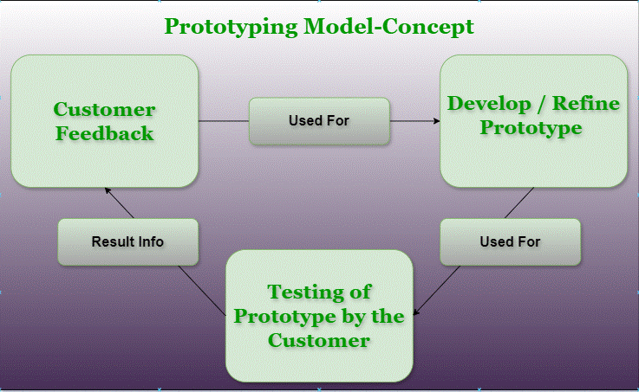
Figure 11-Prototype Model Concept

4.2 GUI Storyboard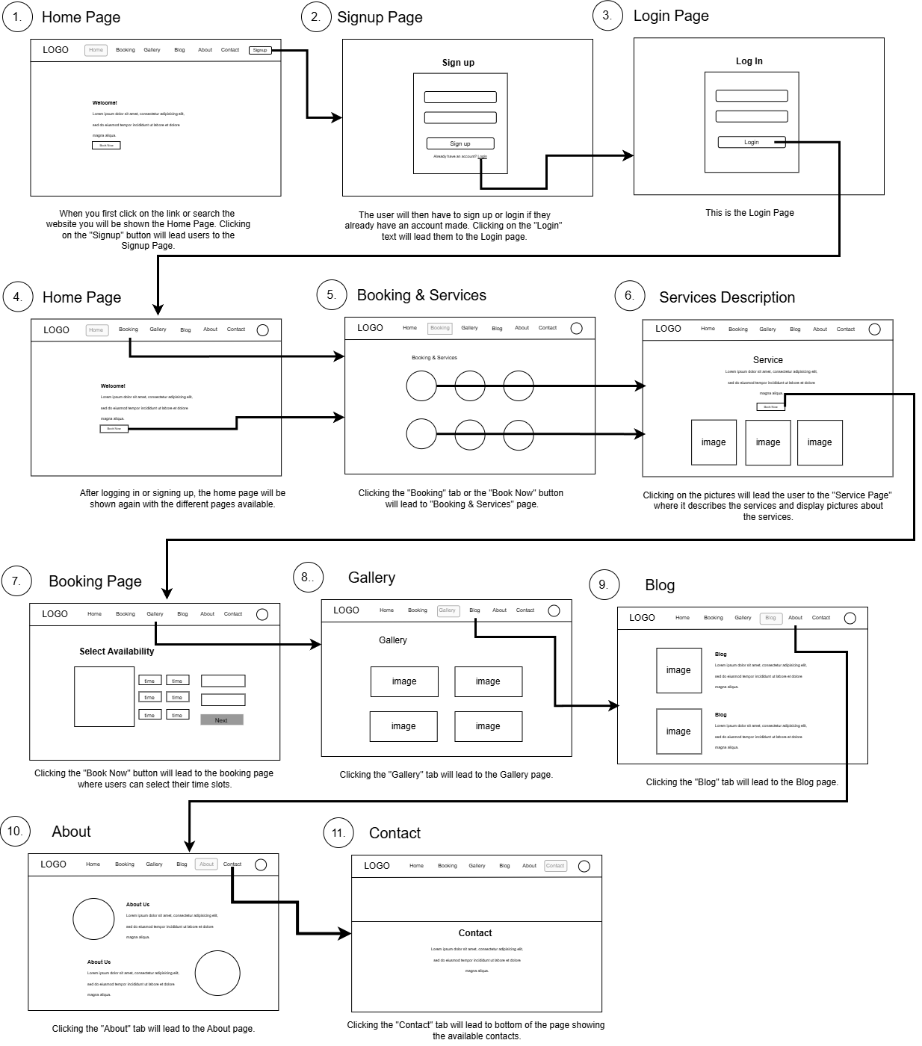
Figure 12-Storyboard of Hotelcatz Website
This storyboard illustrates the user flow for the Hotelcatz website. Each step highlights how users interact with the system with arrows that indicate the links between pages. Below each page, there is a brief description explaining its purpose and functionality.

4.3 GUI Design
Website link: https://reenaa091.wixsite.com/hotelcatz
The HotelCatz website has been designed to be simple, user-friendly, and easy to navigate. Navigation is kept simple with the use of a top menu bar that includes links to all major sections: Home, Booking & Services, Gallery, Blog, About, Contact and Log In.

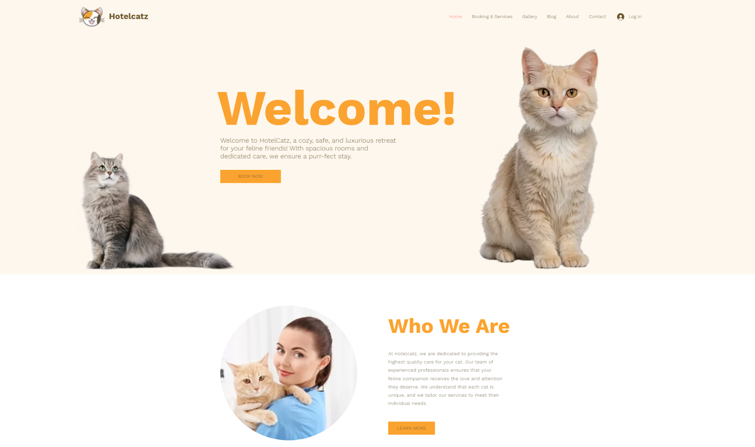
Figure 13-Home Page
The homepage serves as the main hub. It features a Welcome Section with a "Book Now" button that takes users directly to the Booking & Services page. There's also a Who We Are section, where the "Learn More" button leads to the About Page for more details about the brand.
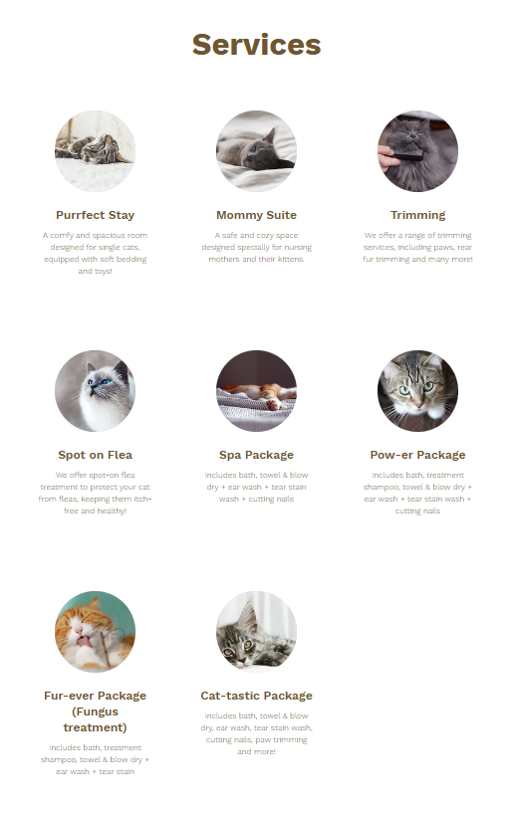
Figure 14-Booking & Services preview in Home Page
The homepage also includes a Booking & Services Preview making it easy for users to explore available options right away.
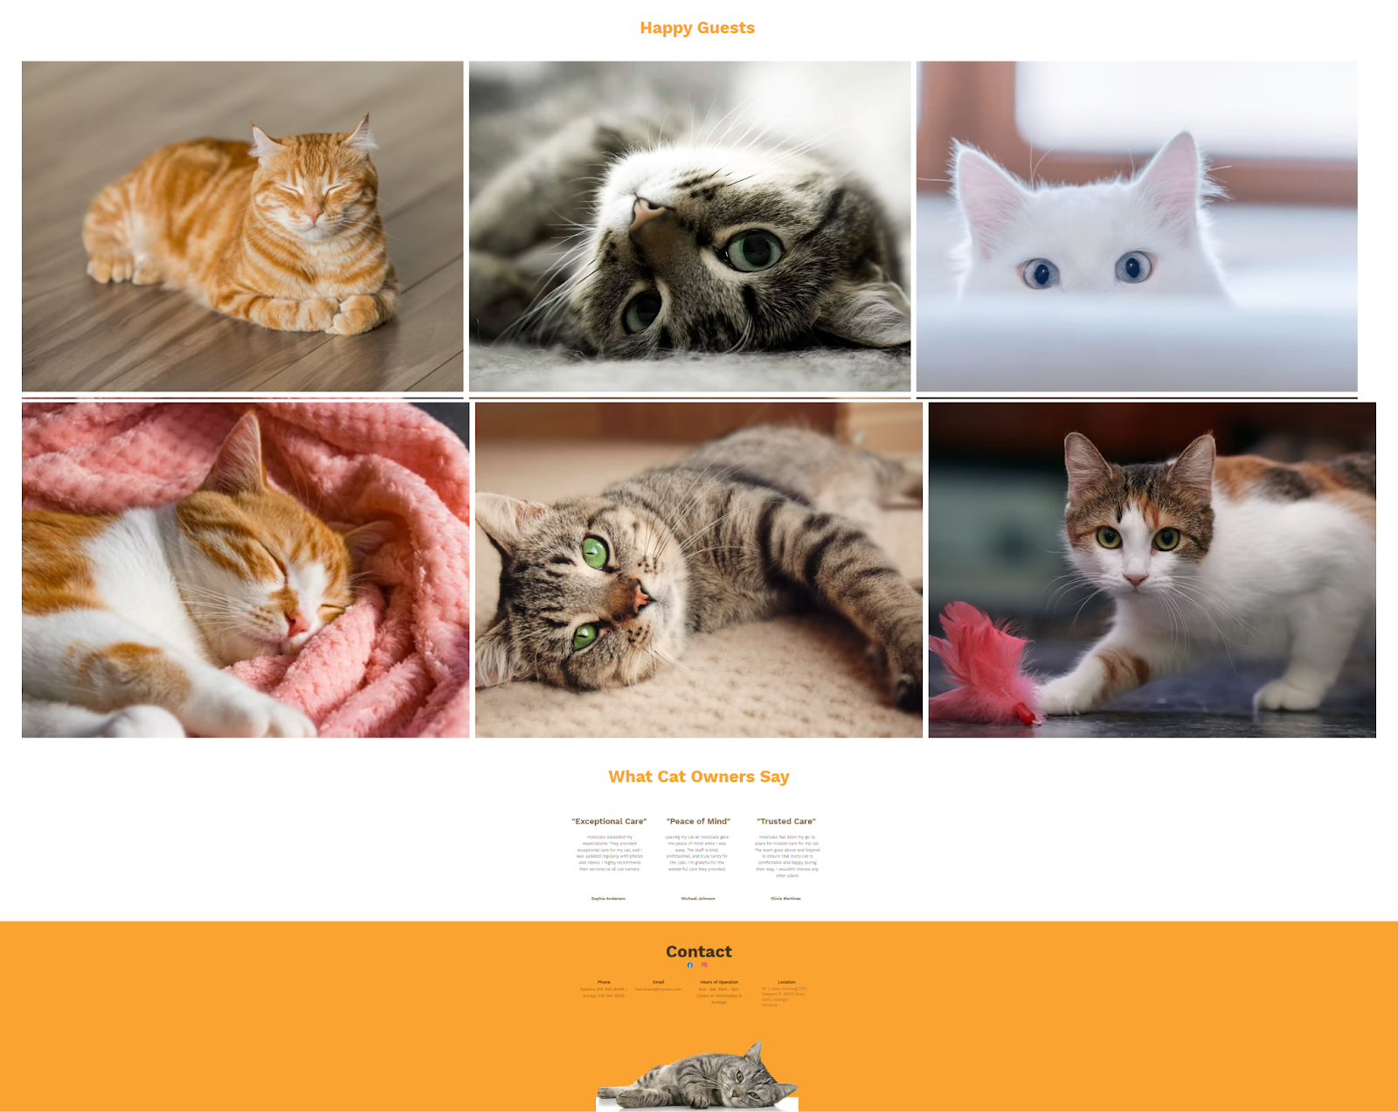
Figure 15-Happy Guests Section in Home Page
The Happy Guests section showcases our adorable little customers who have stayed with us at HotelCatz. The Contact Section at the very end remains visible across all pages. Additionally, clicking "Contact" in the navigation bar simply scrolls back to this section on the homepage for quick access.
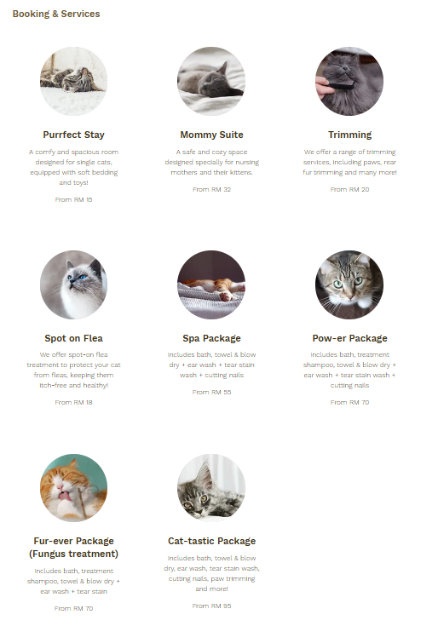
Figure 16-Booking & Services Page
The Booking & Services page is designed to showcase all our available services, each represented by clickable images. Clicking on any of the services, the user will be taken to a dedicated page for that service with more details.
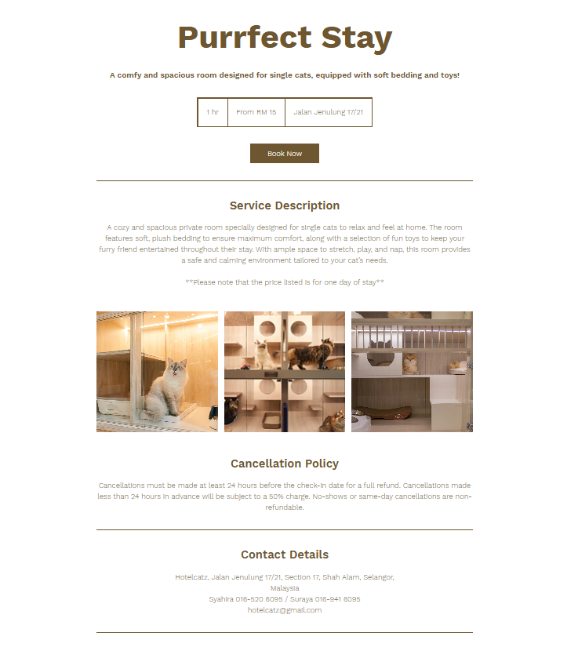
Figure 17-Service Page
From there, they can select “Book Now” to access the booking calendar and schedule an appointment.

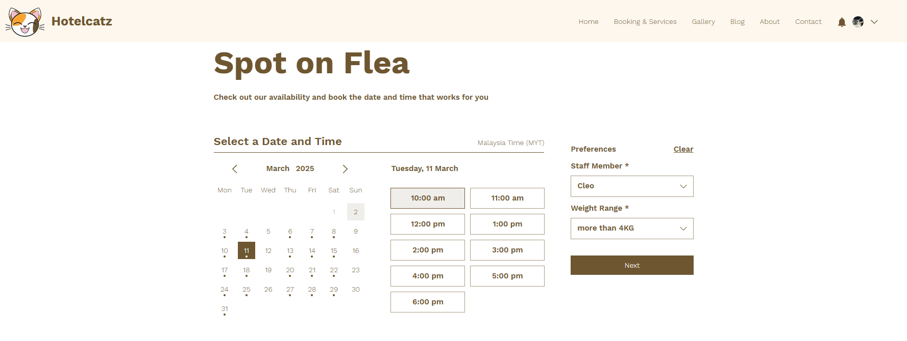
Figure 18-Booking Calendar Page
The Booking Calendar Page where it allows the customers to pick on the day and time where they will be available for the service. Including their preferred staff member and price options.

For our customers who want a visual idea of the place, the Gallery Page features images of the facilities as well as our happy feline guests.
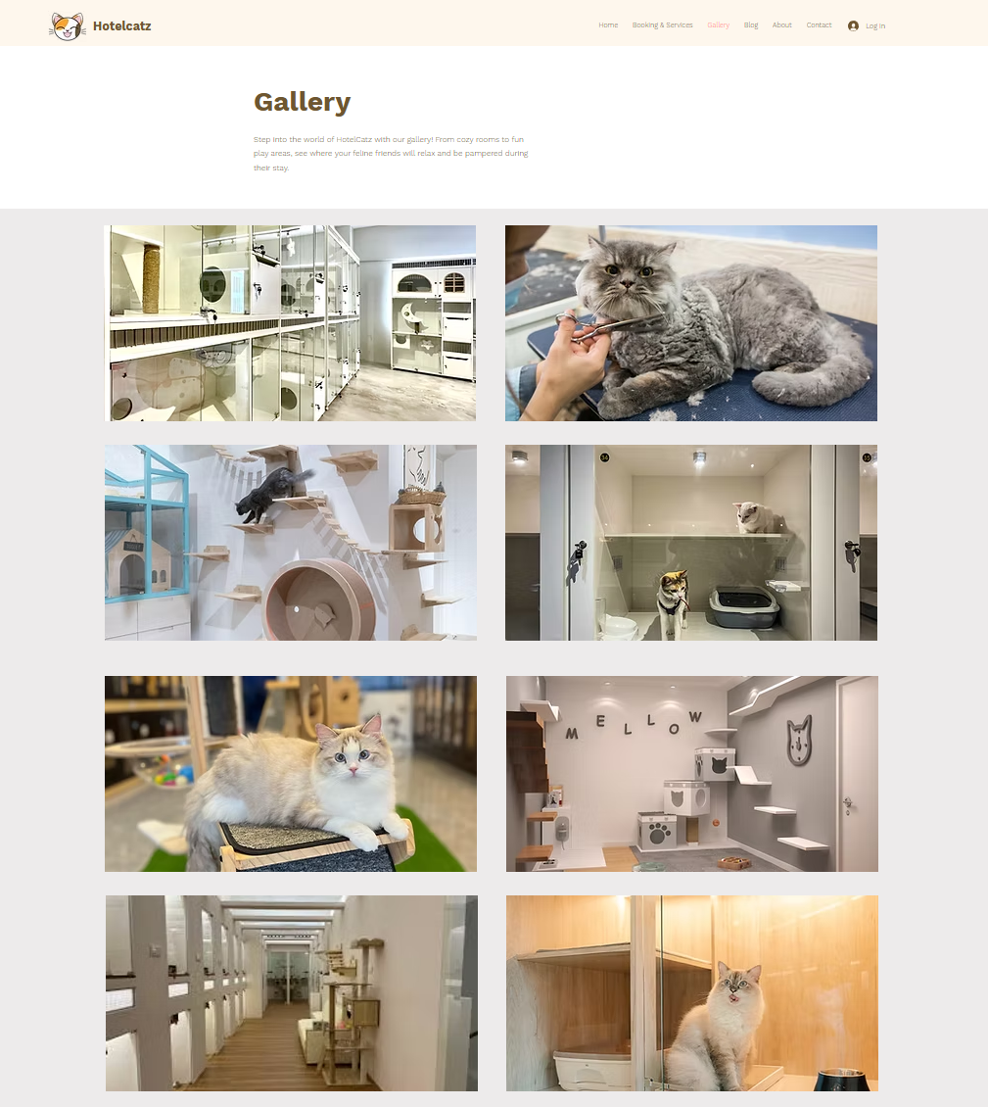
Figure 19-Gallery Page

The Blog Page offers informative content about cat care as well as updates related to the business.
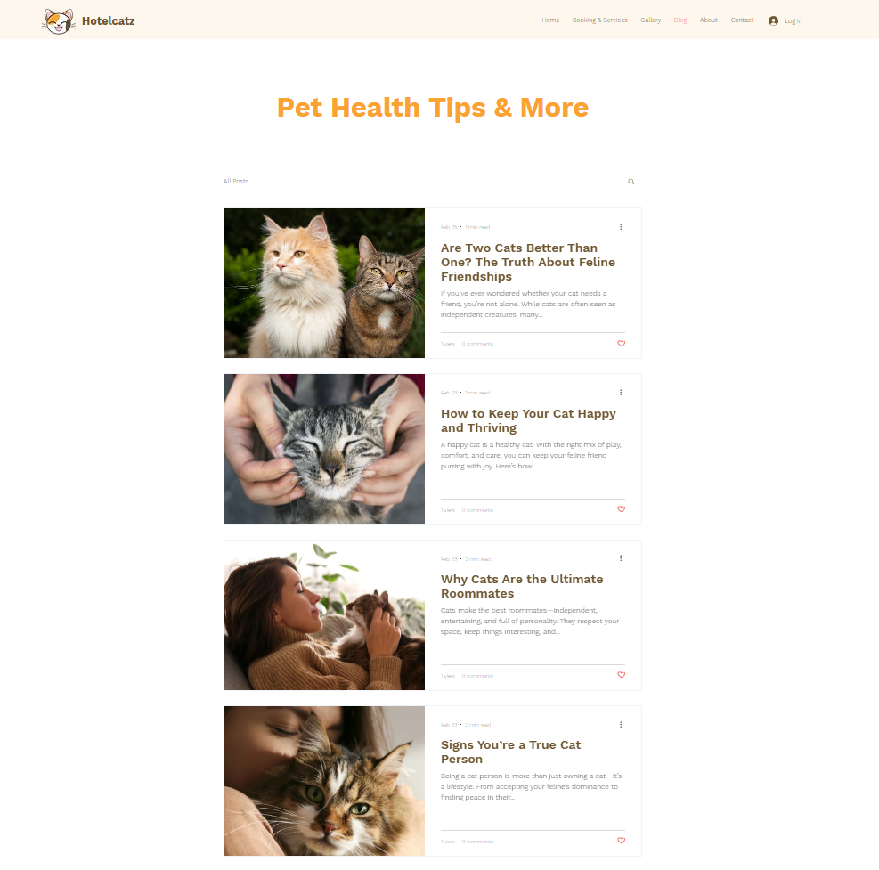
Figure 20-Blog Page

Next, we have the About Page which provides insights into the brand’s story and mission.
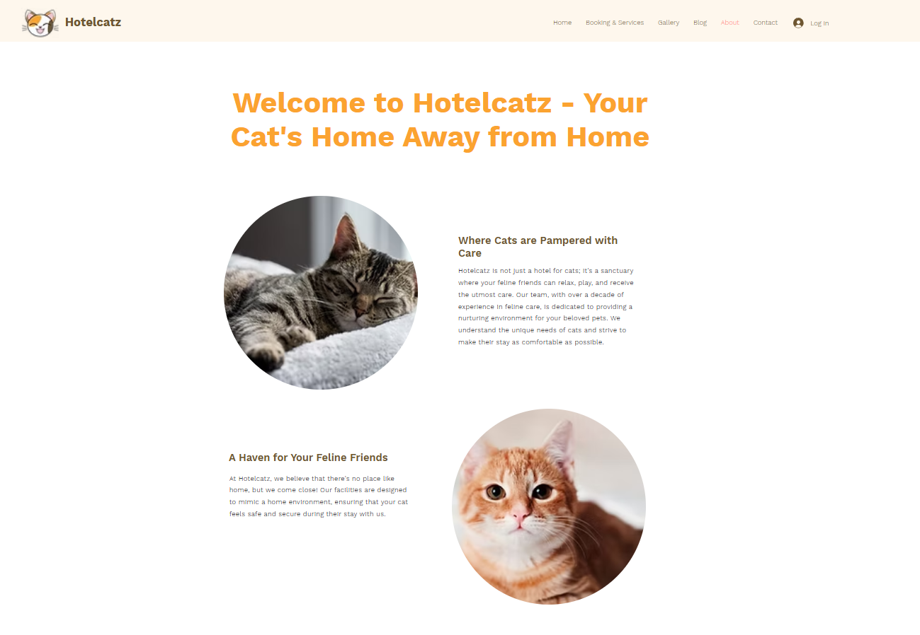
Figure 21-About Us Page
Lastly at the end of the top menu bar, users can click “Log In” to sign in or sign-up using email, Google, or Facebook.
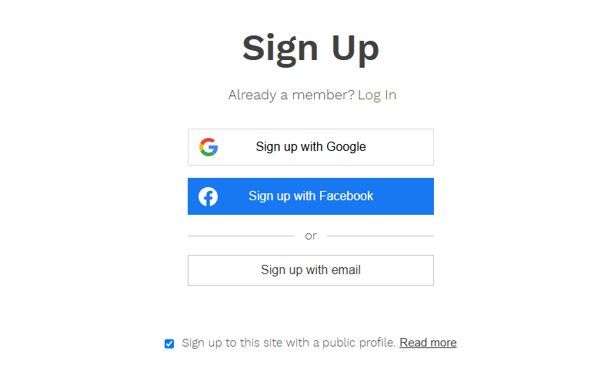
Figure 22-Sign up and Log in Page
Figure 23-Admin Navigation Bar
For Admins, their navigation bar is different from normal users, it has an additional pencil icon which takes the admins to a password page. However, when you click on the prototype link, the icon will be displayed but do note that this will not be visible in the actual website for normal users.
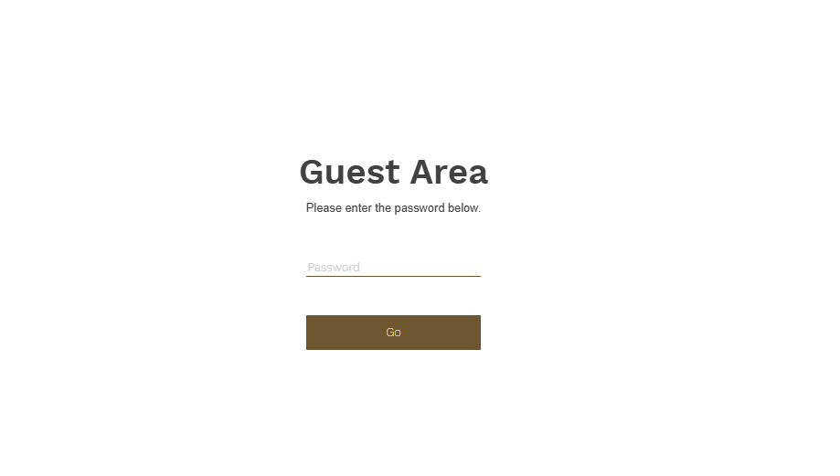
Figure 24-Password Page
On this page, the admin is required to enter the password which is “adminonly”. This will lead them to the admin pages where they will be able to edit and add new contents as well as managing bookings.
The following features mentioned will not be functional in the link provided as this is just a prototype, however in the actual website the features will work as intended.
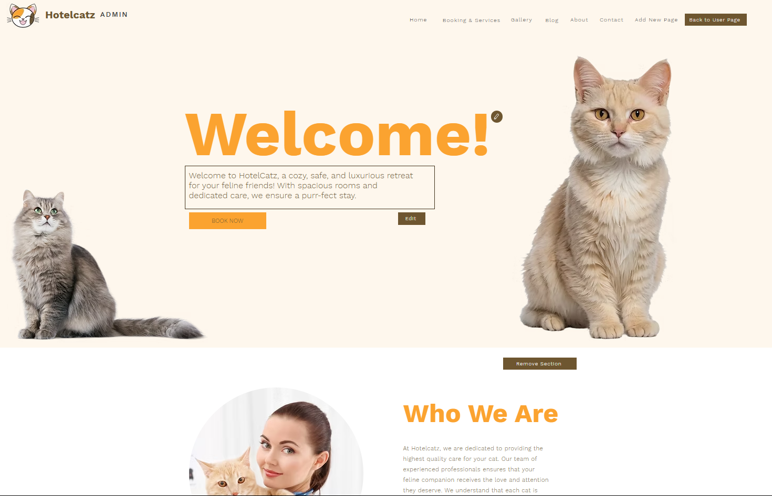
Figure 25-Admin Home Page
On the Home Page, there will be outlines surrounding the texts which allows the admin to edit them followed by pencil icons and “Remove section” buttons around the page.

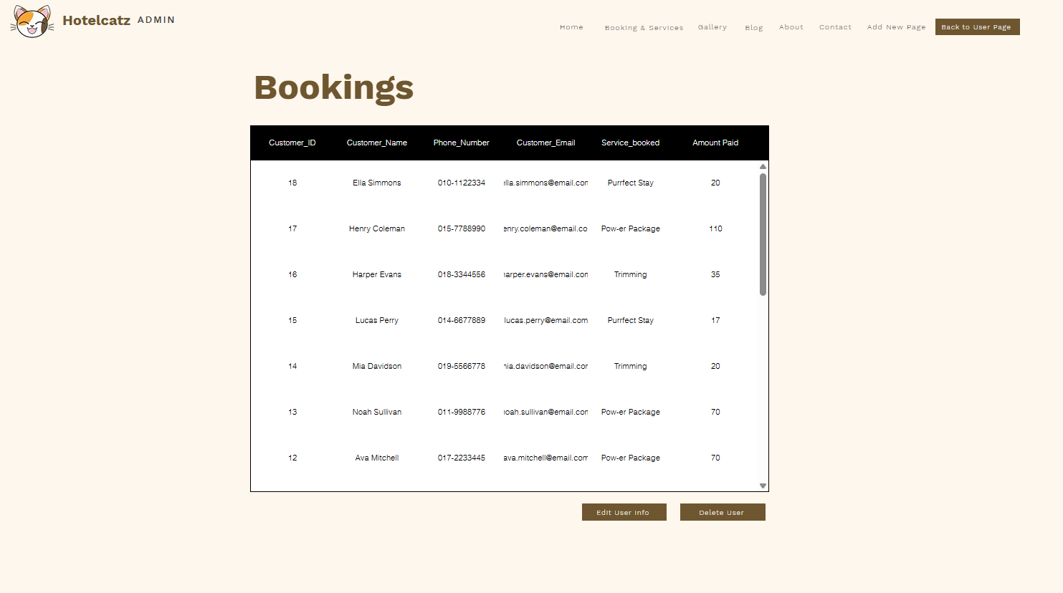
Figure 26-Admin Booking Page
On the Admin Booking page displays a table of records of customers who have booked for the Hotelcatz services. The admins can select the record and edit them or delete the users.
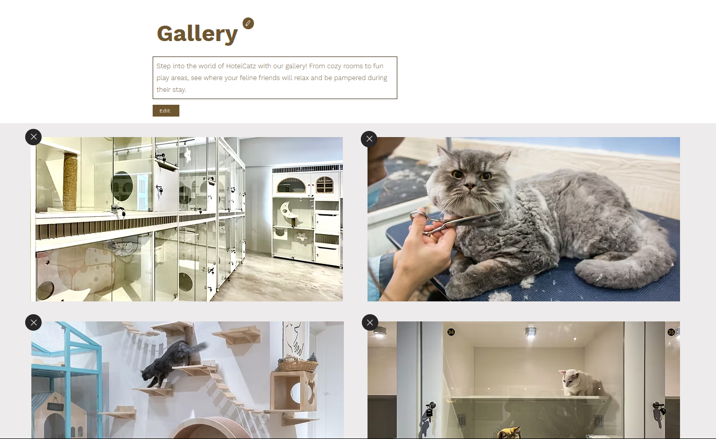
Figure 27-Admin Gallery Page
In the Admin Gallery Page, admins can remove or add new images into the page as well as edit the page title and page description.
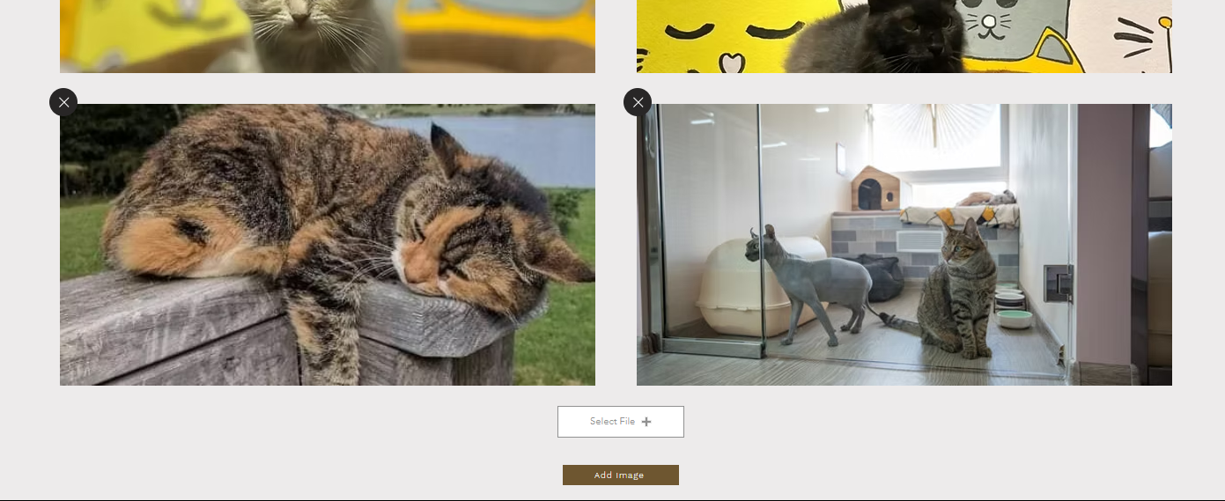
Figure 28-Add New Image Feature
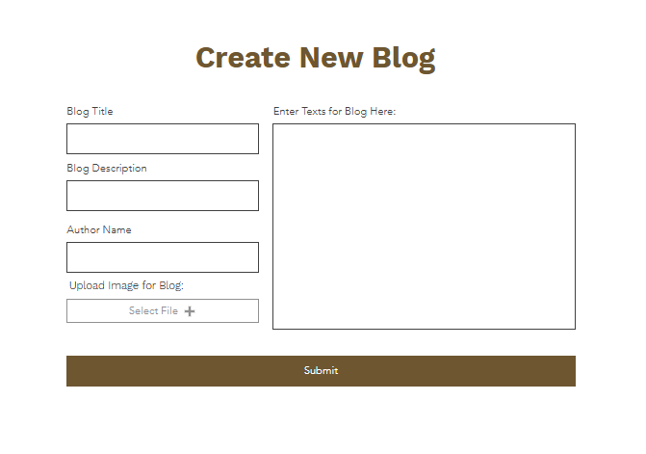
Figure 29-Admin Blog Page
In the Admin Blog Page, is a form where it allows admins to create a new blog.
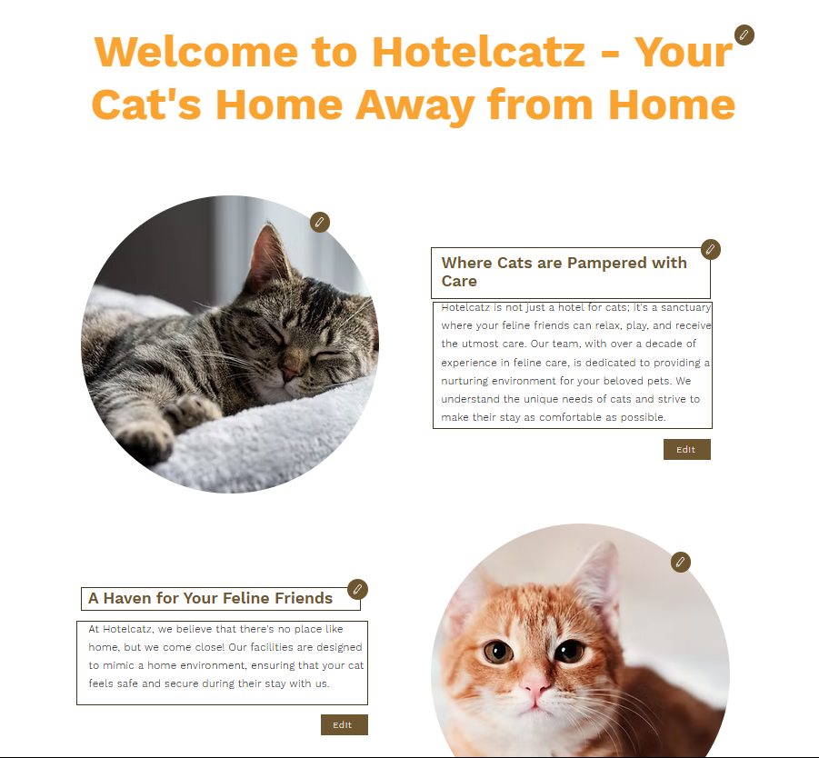
Figure 30-Admin About Page
Similarly to the Admin Home Page, the Admin About Page allows admins to edit the titles, texts and images.
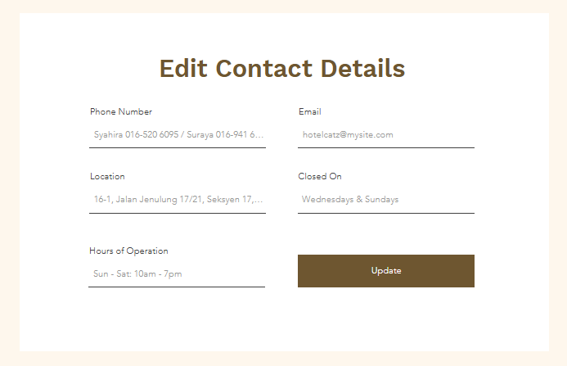
Figure 31-Admin Contact Page
In the Admin Contact Page, allows admins to modify the contact details of the Hotel.
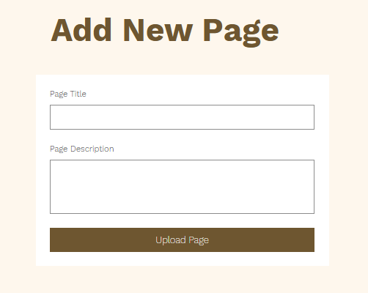
Figure 32-Admin Add New Page
And lastly, the admins can add a new page using the “Add New Page” function where they enter the page title and page description.
Figure 33-Back to User Page
The admin can go back to the normal website by clicking on the “Back to User Page” at the Admin navigation bar.

4.4 Use Case Diagram
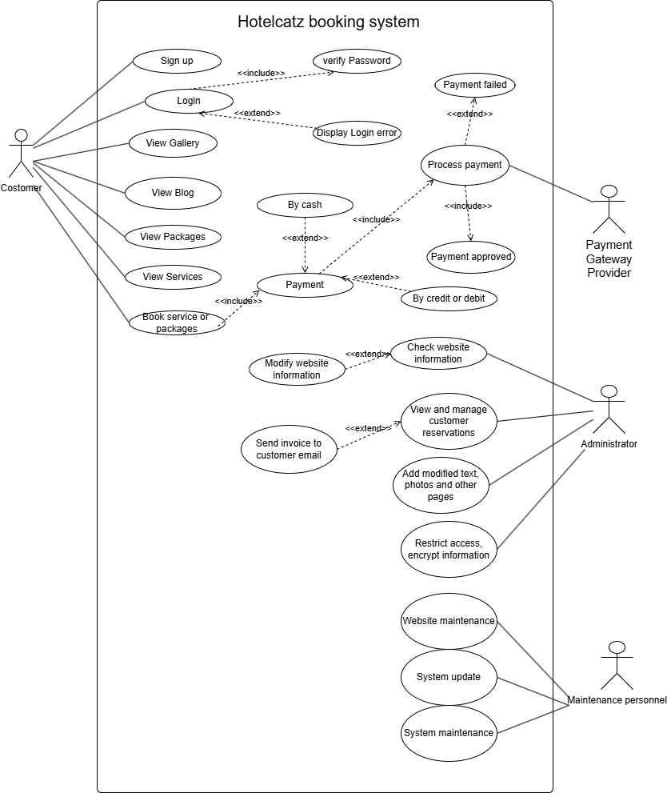
Figure 34-Hotelcatz Use Case Diagram
This is the complete Hotelcatz use case diagram. Here is the explanation of the above diagram:
- Customer-Related Features：
Sign up: The customer can register an account.
Login: The customer can log into the system. his process includes verify Password
View Gallery, View Blog, View Packages, View Services: The customer can browse different sections of the website.
Booking services or packages: When booking, the system requires customers to pay, including cash payment or bank card payment
- Administrator Functions：
View and manage customer reservations:If the customer pays and the reservation is successful, the administrator will send the order information to the customer's email.
Check website information:If there is a problem with the information, the administrator has the function to modify the website information.
Add modified text, photos and other pages.
Restrict access, encrypt information.
- Maintenance Personnel Functions
Website maintenance.
System update.
System maintenance.
- Payment Gateway Provider Function
Process payment:the third party will check whether the customer has made a successful payment and send a message to the administrator if the payment is successful.

4.5 Class Diagram
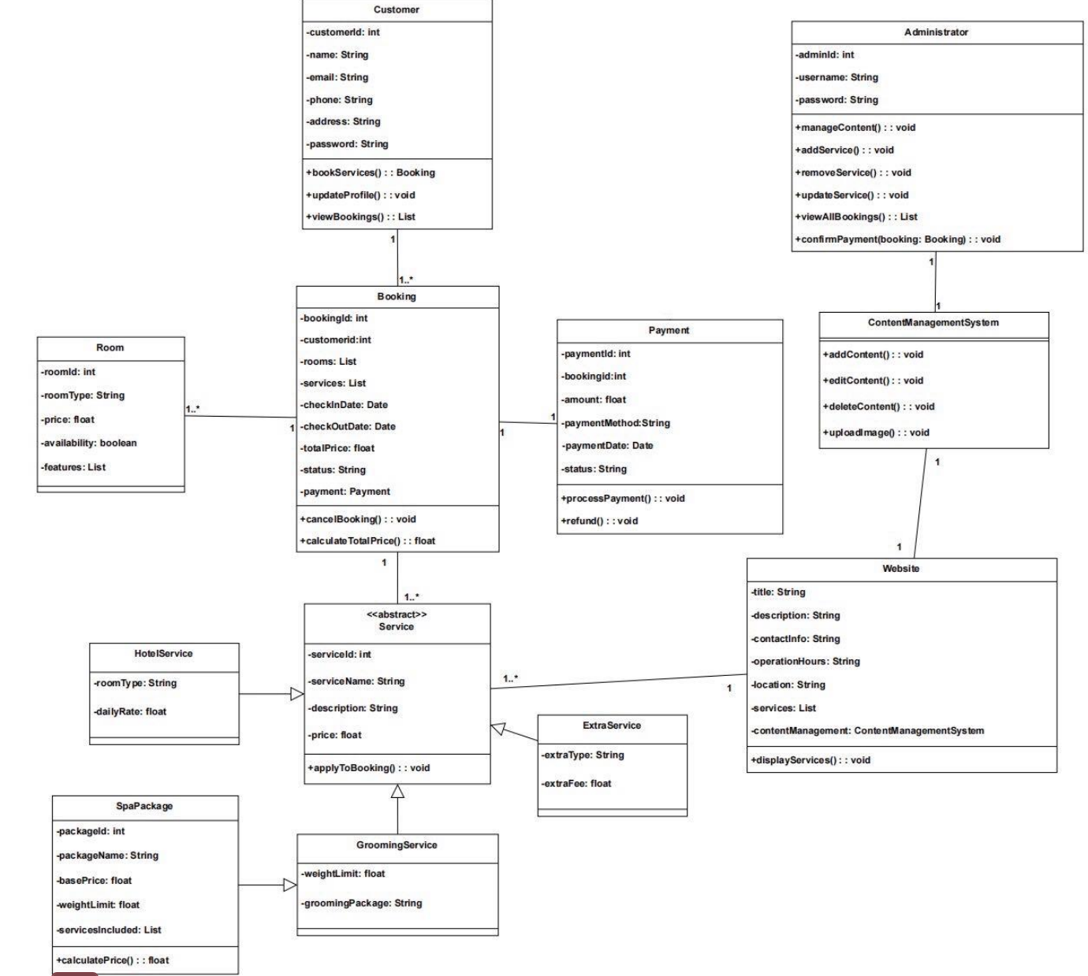
Figure 35-Hotelcatz Class Diagram
This UML class diagram illustrates the model of a hotel management system. Customers can initiate Bookings, and there is an association relationship between Customers and Bookings. Administrators can manage various Services, and an association exists between them. Rooms are a part of Bookings, which is an aggregation relationship. Payment depends on Bookings and provides payment operations for them. Services are generalized into specific service types such as Hotel Services, Spa Packages, and Grooming Services. Extra Services serve as a supplement to Services. The Website is associated with the Content Management System to manage and display content and services.

4.6 Sequence Diagram
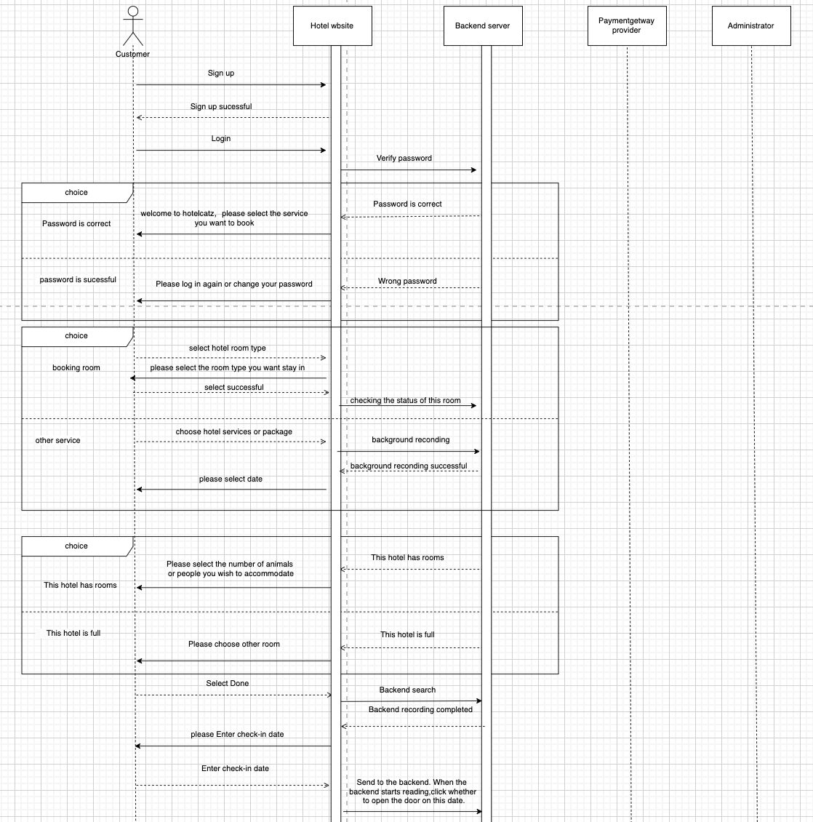
Figure 36-Hotelcatz Sequence Diagram Part 1
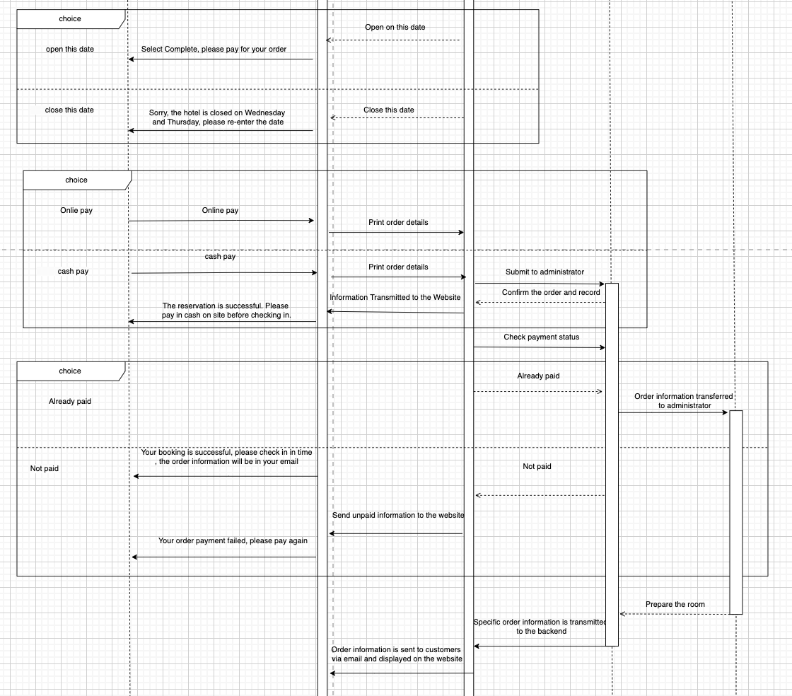
Figure 37-Hotelcatz Sequence Diagram Part 2
- The customer first registers an account and then logs in. The background will check whether the login password is correct. If there is no error, the login is successful. The customer selects and makes an appointment for the required service. If there is an error, the customer is required to log in again and change the password.
- The services include room reservation and other services (manicure, haircut, cat bath). If the customer chooses room reservation, the background will check whether the room is full. If the customer chooses to book other services, it will directly enter the date selection option.
- After selecting a room, the customer enters the check-in date or service date, and the date will show whether the hotel is open.
- After the date selection is completed, you will directly enter the payment page. Payment is divided into online payment and cash payment. After the customer chooses online payment, the order will be printed and the backend administrator will inquire about the payment status with the third party. If the payment has been made, the administrator will prepare the room and send the order information and invoice to the patient by email.
- When choosing to pay in cash, the information will be transmitted to the background and then to the administrator. After the administrator completes the record, he will remind the customer that the reservation is successful. The customer must complete the payment before they can check in.

5.0 Conclusion

The HotelCatz website functions as an effective and intuitive platform aimed at helping customers who want to book boarding services for their cats alongside other types of treatment. We have undertaken a systematic approach to software engineering to ensure that not only customers can easily access our services but also administrators can effectively manage reservations and website content. To improve an overall experience, we also implemented a secure login, real-time availability checks for rooms, and a booking confirmation system.
However, our current system is not free of certain limitations. Since we are using the free version of Wix, our payment processing capabilities are limited. This means that we are unable to test live transactions. This reliance on third-party payment gateways can have potential risks such as delays or transaction issues. Also, users cannot book the hotel rooms for more than one day due to wix limitations as well. Furthermore, system failures like downtime or security vulnerabilities could affect both customers and administrators.
For the improvement of the system, we can add two-factor authentication as an enhanced security measure. Using AI chatbots in the system would boost customer participation while speeding up the process of handling user queries. The system would also benefit from mobile app development to enhance accessibility. System stability together with failure prevention can be achieved through regular performance tests and audits. The HotelCatz website will transform into a better user-friendly platform through these implemented updates to satisfy the growing needs of pet owners and administrators.

Group Rubrics
Criteria (Weight) | Unacceptable (0) | Marginal (1) | Acceptable (2) | Exceptional (3) | Points
Design Problem and Boundaries via  SDLC  (10) | 0-2  Little or no grasp of problem. Incapable of  producing a successful solution. | 3-5  Some understanding of problems. Major  deficiencies that will impact the quality of solution. | 6-8  Overall understanding of the problem and  constraints. Does not significantly impair solution. | 9-10  Clear and complete understanding of  design goals and constraints.
Alternative Designs  (10) | 0-2  Only one design presented or clearly  infeasible alternative given. | 3-5  Serious deficiencies in exploring and  identifying alternative designs. | 6-8  Alternative approaches identified to some degree. | 9-10  Final design achieved after review of reasonable  alternatives.
Use of Computer–  Aided Tools  (10) | 0-2  Serious deficiencies in understanding the  correct selection and/or use of tools. | 3-5 Minimal application and use of appropriate tools. | 6-8  Computer–aided tools used with moderate  effectiveness to develop designs. | 9-10  Computer–aided tools are used effectively to develop and analyze designs.
UML diagram  (20) | 0-8  No or erroneous application of UML principles yielding unreasonable solution. | 9-12  Serious deficiencies in proper selection and use of UML principles. | 13-15  Effective application of  UML principles resulting in reasonable solution. | 16-20  Critical selection and application of UML principles ensuring reasonable results.
Final report  (10) | 0-2  Not capable of achieving desired objectives.  No implementation of project resources and client requirements. | 3-5 Barely capable of achieving desired objectives.  Minimal utilization of resources and client requirements. | 6-8  Report meets desired objectives.  Moderately effective utilization of resource and client requirements. | 9-10 Report meets or exceeds desired objectives.  Effective implementation of  resource and client requirements.

